
SCHOOL OF COMPUTING AND ENGINEERING SCIENCES (SCES)
BACHELOR OF SCIENCE IN ELECTRICAL AND ELECTRONICS ENGINEERING (BSEEE)
SEMESTER TWO: REPORT ON CYCLOALKANEs AND ALKANES

By
Mwongela Edward Aribu 142092
Teddy Mbugua - 142776
Mark Mbiriri - 143389
Arnold Injeni - 146279

Abstract
This is a report compiled by chemistry group 4 members after research done on alkanes and cycloalkanes. It comprises of their chemical and physical characteristics, the types, physical structures and the various uses or applications.

Contents
Abstract 2
Table of figures 4
INTRODUCTION 5
ALKANES 5
CYCLOALKANES 5
What are cycloalkanes? 5
PROPERTIES AND STRUCTURE OF ALKANES 6
PHYSICAL PROPERTIES 6
CHEMICAL PROPERTIES 7
PROPERTIES AND STRUCTURE OF CYCLOALKANES 8
PHYSICAL PROPERTIES 8
CHEMICAL PROPERTIES 8
STRUCTURES OF ALKANES 10
STRUCTURE OF CYCLOALKANES 16
APPLICATIONS OF ALKANES 19
REFERENCES 20

Table of figures
Figure 1:addition in spiro cycloalkane 8
Figure 2 8
Figure 3 9
Figure 4 9
Figure 5 13
Figure 6 14
Figure 7 15
Figure 8:polygons representing cycloalkanes 16
Figure 9 :bridgehead carbon atoms 16
Figure 10:acrtlic compounds 17

INTRODUCTION

ALKANES
Alkanes are a series of compounds that contain carbon and hydrogen atoms with single covalent bonds. These are known as saturated hydrocarbons. This group of compounds consists of carbon and hydrogen atoms with single covalent bonds(Alkanes - Formula, Definition, Structure, Properties, List of Alkanes, Videos, Examples and FAQS of Alkanes., n.d.)
The key steps in the naming of more complicated branched alkanes are as follows:
- Identify the longest continuous chain of carbon atoms
- Name this longest root chain using standard naming rules
- Name each side chain by changing the suffix of the name of the alkane from "-ane" to "-yl"
- Number the longest continuous chain to give the lowest possible numbers for the sidechains
- Number and name the side chains before the name of the root chain
- If there are multiple side chains of the same type, use prefixes such as "di-" and "tri-" to indicate it as such, and number each one.
- Add side chain names in alphabetical (disregarding "di-" etc. prefixes) order in front of the name of the root chain
The name of the compound is written out with the substituents in alphabetical order followed by the base name (derived from the number of carbons in the parent chain). Commas are used between numbers and dashes are used between letters and numbers. There are no spaces in the name.

CYCLOALKANES

What are cycloalkanes?
Cycloalkanes are cyclic hydrocarbons, meaning that the carbons of the molecule are arranged in the form of a ring. Cycloalkanes are also saturated, meaning that all the carbons atoms that make up the ring are single bonded to other atoms (no double or triple bonds). There are also polycyclic alkanes, which are molecules that contain two or more cycloalkanes that are joined, forming multiple rings

PROPERTIES AND STRUCTURE OF ALKANES
An alkane is an acyclic saturated hydrocarbon. In other words, an alkane consists of hydrogen and carbon atoms arranged in a tree structure in which all the carbon–carbon bonds are single. Alkanes have the general chemical formula C_{n}H_{2n+2}. The alkanes range in complexity from the simplest case of methane (CH4), where n = 1 (sometimes called the parent molecule), to arbitrarily large and complex molecules, like pentacontane (C₅₀H₁₀₂) or 6-ethyl-2-methyl-5-(1-methylethyl) octane, an isomer of tetradecane (C₁₄H₃₀).(“Alkane,” 2022)
The first four names were derived from methanol, ether, propionic acid, and butyric acid. Alkanes with five or more carbon atoms are named by adding the suffix -ane.

PHYSICAL PROPERTIES
- Alkanes experience intermolecular van der Waals forces. Stronger intermolecular van der Waals forces give rise to greater boiling points of alkanes
There are two determinants for the strength of the van der Waals forces:
- the number of electrons surrounding the molecule, which increases with the alkane's molecular weight
- the surface area of the molecule
Under standard conditions, from CH4 to C4H10 alkanes are gaseous; from C5H12 to C17H36 they are liquids; and after C18H38 they are solids
A straight-chain alkane will have a boiling point higher than a branched-chain alkane due to the greater surface area in contact, thus the greater van der Waals forces, between adjacent molecules.
- The melting points of the alkanes follow a similar trend to boiling points. As the intermolecular Van Der Waals forces increase with the increase of the molecular size or the surface area of the molecule we observe
Generally, the larger the molecule the higher the melting point due to increasing molecular weight,
The melting points of branched-chain alkanes can be either higher or lower than those of the corresponding straight-chain alkanes, again depending on the ability of the alkane in question to pack well in the solid phase.
- Alkanes do not conduct electricity in any way, nor are they substantially polarized by an electric field. For this reason, they do not form hydrogen bonds and are insoluble in polar solvents such as water
Due to very little difference of electronegativity between carbon and hydrogen and covalent nature of C-C bond or C-H bond, alkanes are generally non-polar molecules. As we generally observe, polar molecules are soluble in polar solvents whereas non-polar molecules are soluble in non-polar solvents.

CHEMICAL PROPERTIES
- Alkanes are only weakly reactive with most chemical compounds. The acid dissociation constant (pKa) values of all alkanes are estimated to range from 50 to 70, hence they are extremely weak acids that are practically inert to bases.
- All alkanes react with oxygen in a combustion reaction, although they become increasingly difficult to ignite as the number of carbon atoms increases.
- Alkanes react with halogens in a so-called free radical halogenation reaction. The hydrogen atoms of the alkane are progressively replaced by halogen atoms. Free radicals (In chemistry, a free radical is an atom, molecule, or ion that has at least one unpaired valence electron. With some exceptions, these unpaired electrons make radicals highly chemically reactive.) are the reactive species that participate in the reaction, which usually leads to a mixture of products.
- Cracking breaks larger molecules into smaller ones. This can be done with a thermal or catalytic method. The catalytic cracking process involves the presence of acid catalysts
- Isomerization and reformation are processes in which straight-chain alkanes are heated in the presence of a platinum catalyst.
- In isomerization, the alkanes become branched-chain isomers. In other words, it does not lose any carbons or hydrogens, keeping the same molecular weight
- In reformation, the alkanes become cycloalkanes or aromatic hydrocarbons, giving off hydrogen as a by-product.
- Alkanes will react with steam in the presence of a nickel catalyst to give hydrogen.

PROPERTIES AND STRUCTURE OF CYCLOALKANES

PHYSICAL PROPERTIES
(i) First two members are gases, the next three members are liquids, and the higher ones are solids.
(ii) They are not soluble in water but soluble in alcohol and ether.
(iii) Their boiling points show a gradual increase with the increase of molecular mass. Their boiling points are higher than those of isomeric alkenes or corresponding alkanes.
(iv) Their density increases gradually with the increase of molecular mass.

CHEMICAL PROPERTIES
Cycloalkanes behave both like alkenes and alkanes in their chemical properties. All cycloalkanes undergo substitution reaction with halogen in the presence of light (like alkane). All cycloalkane (lower members) undergoes addition reaction (ex. Addition of H₂, HX, X₂). Further the tendency of forming addition compounds decreases with increase in size of ring cyclopropane > Cyclobutane > Cyclopentane. Relative ring opening of ring is explained by Baeyer strain theory.
(i) Addition in spiro cycloalkane: If two cycloalkanes fused with one another then addition take place in small ring
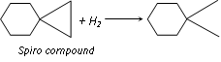
Figure 1:addition in spiro cycloalkane

Because small ring is more unstable than large ring
Higher cycloalkanes do not give addition due to more stability.

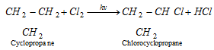
Figure 2
(iii) Addition reaction
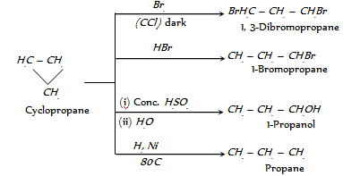
Figure 3
(iv) Oxidation
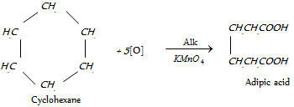
Figure 4

STRUCTURES OF ALKANES
Alkanes with more than three carbon atoms can be arranged in various ways, forming structural isomers. In chemistry, a structural isomer of a compound is another compound whose molecule has the same number of atoms of each element, but with logically distinct bonds between them.
The simplest isomer of an alkane is the one in which the carbon atoms are arranged in a single chain with no branches.
The number of possible isomers increases rapidly with the number of carbon atoms. For example:
- C1: methane only; Methane is a chemical compound with the chemical formula CH₄ (one carbon atom bonded to four hydrogen atoms)
- C2: ethane only; Ethane is an organic chemical compound with chemical formula C₂H_{6.} At standard temperature and pressure, ethane is a colourless, odourless gas.
- C3: propane only; Propane is a three-carbon alkane with the molecular formula C₃H₈. It is a gas at standard temperature and pressure, but compressible to a transportable liquid.
- C4: 2 isomers: butane and isobutane
- C5: 3 isomers: pentane, isopentane, and neopentane
- C6: 5 isomers: hexane, 2-methylpentane, 3-methylpentane, 2,2-dimethylbutane, and 2,3-dimethylbutane
- C7: 9 isomers: heptane, methylhexane (2 isomers), dimethylpentane (4 isomers), 3-ethylpentane, 2,2,3-trimethylbutane
- C8: 18 isomers: octane, 2-methylheptane, 3-methylheptane, 2,3-dimethylhexane, 3,4-dimethylhexane, 2,3,4-trimethylpentane, 3,3-dimethylhexane, 2,2-trimethylpentane, 2,4-dimethylhexane, 2,2,4-trimethylpentane, 2,3,3-Trimethylpentane, 3,3,4-trimethyl-pentane, 3,4,4-trimethylpentane, 2,4,4-trimethylpentane, (5 isomers)
- C9: 35 isomers
- C10: 75 isomers
- C12: 355 isomers
- C32: 27,711,253,769 isomers
- C60: 22,158,734,535,770,411,074,184 isomers, many of which are not stable.
Alkane | Formula | Boiling point [°C] | Melting point [°C] | Density [kg/m³] (at 20 °C) | Isomers
Methane | CH₄ | −162 | −182 | 0.656 (gas) | 1
Ethane | C₂H₆ | −89 | −183 | 1.26 (gas) | 1
Propane | C₃H₈ | −42 | −188 | 2.01 (gas) | 1
Butane | C₄H₁₀ | 0 | −138 | 2.48 (gas) | 2
Pentane | C₅H₁₂ | 36 | −130 | 626 (liquid) | 3
Hexane | C₆H₁₄ | 69 | −95 | 659 (liquid) | 5
Heptane | C₇H₁₆ | 98 | −91 | 684 (liquid) | 9
Octane | C₈H₁₈ | 126 | −57 | 703 (liquid) | 18
Nonane | C₉H₂₀ | 151 | −54 | 718 (liquid) | 35
Decane | C₁₀H₂₂ | 174 | −30 | 730 (liquid) | 75
Undecane | C₁₁H₂₄ | 196 | −26 | 740 (liquid) | 159
Dodecane | C₁₂H₂₆ | 216 | −10 | 749 (liquid) | 355
Tridecane | C₁₃H₂₈ | 235 | −5.4 | 756 (liquid) | 802
Tetradecane | C₁₄H₃₀ | 253 | 5.9 | 763 (liquid) | 1858
Pentadecane | C₁₅H₃₂ | 270 | 10 | 769 (liquid) | 4347
Hexadecane | C₁₆H₃₄ | 287 | 18 | 773 (liquid) | 10,359
Heptadecane | C₁₇H₃₆ | 303 | 22 | 777 (solid) | 24,894
Octadecane | C₁₈H₃₈ | 317 | 28 | 781 (solid) | 60,523
Nonadecane | C₁₉H₄₀ | 330 | 32 | 785 (solid) | 148,284
Icosane | C₂₀H₄₂ | 343 | 37 | 789 (solid) | 366,319
Triacontane | C₃₀H₆₂ | 450 | 66 | 810 (solid) | 4,111,846,763
Tetracontane | C₄₀H₈₂ | 525 | 82 | 817 (solid)
Pentacontane | C₅₀H₁₀₂ | 575 | 91 | 824 (solid)
Hexacontane | C₆₀H₁₂₂ | 625 | 100 | 829 (solid)
Heptacontane | C₇₀H₁₄₂ | 653 | 109 | 869 (solid)

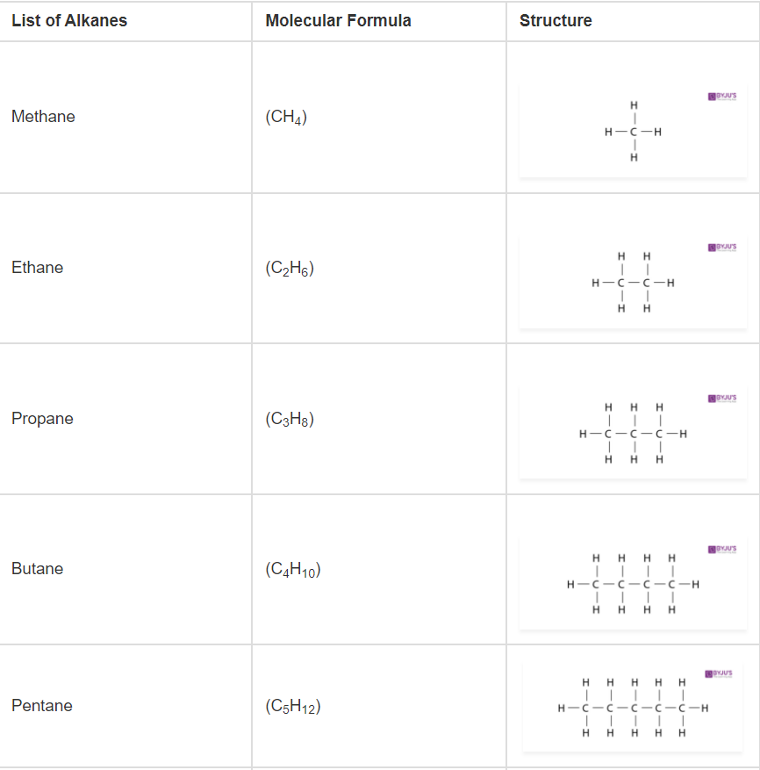
Figure 5

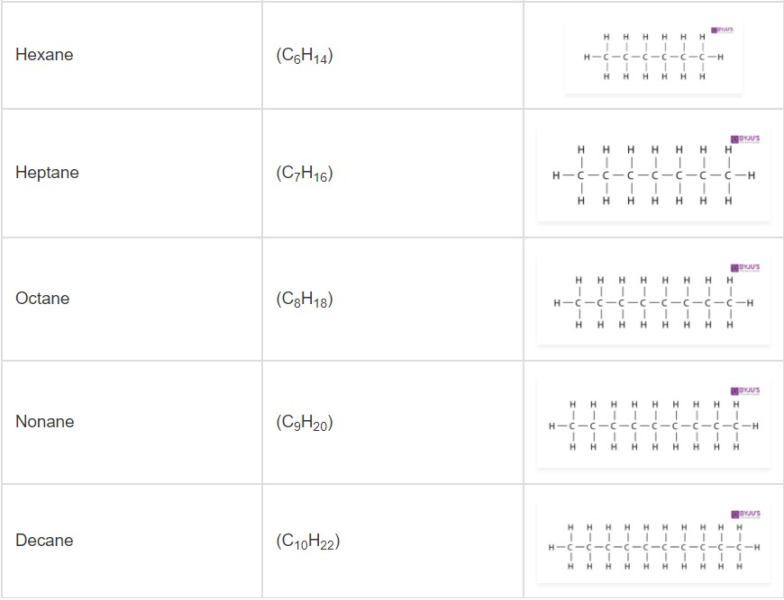
Figure 6
(Alkanes, n.d.)
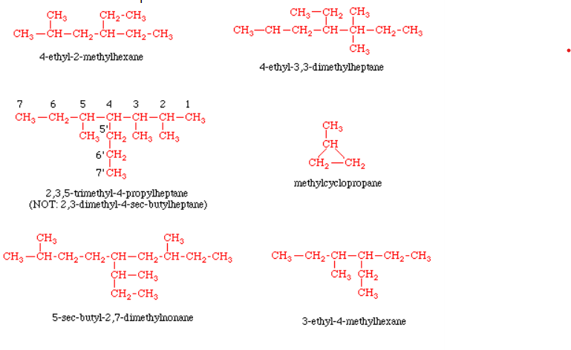
Figure 7

STRUCTURE OF CYCLOALKANES
Cycloalkanes with one ring have the general formula C_{n}H_{2n} compared with the general formula C_{n}H_{(2n + 2)} for acyclic alkanes. Cycloalkanes have two fewer hydrogen atoms than alkanes because another carbon-carbon bond is needed to form the ring. Cycloalkanes are drawn as simple polygons in which the sides represent the carbon-carbon bonds. It is understood that each corner of the polygon is a carbon atom bonded to two hydrogen atoms.

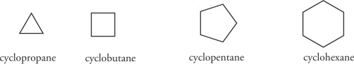
Figure 8:polygons representing cycloalkanes
Multiple rings in a molecule can share one or more common atoms. Spirocyclic compounds share one carbon atom between two rings. These compounds are relatively rare in nature. Fused ring compounds share two common atoms and the bond between them. These compounds are prevalent in steroids, which contain four fused rings. Bridged ring compounds share two nonadjacent carbon atoms called bridgehead carbon atoms. These compounds are less prevalent than fused ring compounds but more common than spirocyclic compounds. A few examples are shown as follows.

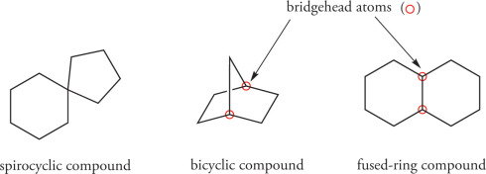
Figure 9 :bridgehead carbon atoms
Each ring system shown above has two rings: they are bicyclic compounds. We can easily see this for the spirocyclic and fused ring compounds. The bridged ring compound appears to have three rings at first sight, but it has only two. We can determine how
many rings are present in a ring system by determining the minimum number of “cuts” that are required to give an acyclic compound. Two such cuts are necessary for the bridged ring system shown above. The first cut gives a single ring, and the second cut gives an acrylic compound.
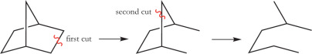
Figure 10:acrtlic compounds

Cycloalkane | Molecular Formula | Basic Structure
Cyclopropane | C₃H₆ | 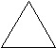
Cyclobutene | C₄H₈ | 
Cyclopentane | C₅H₁₀ | 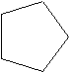
Cyclohexane | C₆H₁₂ | 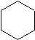
Cycloheptane | C₇H₁₄ | 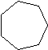
Cyclooctane | C₈H₁₆ | 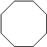
Cyclononane | C₉H₁₈ | 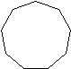
Cyclodecane | C₁₀H₂₀ | 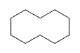

APPLICATIONS OF ALKANES
The applications of alkanes depend on the number of carbon atoms.
- The first four alkanes are used mainly for heating and cooking purposes, and in some countries for electricity generation.
- Propane - propane gas burners, fuel for vehicles, propellant in aerosol sprays
- Butane – space heaters, disposable cigarette lighters, propellant in aerosol sprays
- Pentane to octane - fuels for combustible engines
(Branched-chain alkanes are preferred as they are much less prone to premature ignition, which causes knocking, than their straight-chain homologues. This propensity to premature ignition is measured by the octane rating of the fuel, where 2,2,4-trimethylpentane (isooctane) has an arbitrary value of 100, and heptane has a value of zero.)
- nonane to hexadecane - form major parts of diesel and aviation fuel
- hexadecane upwards – form components pf fuel oil and lubricating oil
- Many solid alkanes find use as paraffin wax, for example, in candles
- Alkanes with a chain length of approximately 35 or more carbon atoms are found in bitumen, used, for example, in road surfacing.

REFERENCES
https://byjus.com/chemistry/cycloalkanes/
https://www.sciencedirect.com/topics/chemistry/cycloalkane
https://chem.libretexts.org/Bookshelves/Organic_Chemistry/Supplemental_Modules_(Organic_Chemistry)/Alkanes/Properties_of_Alkanes/Cycloalkanes/Physical_Properties_of_Cycloalkanes
http://www.expertsmind.com/learning/physical-and-chemical-properties-of-cycloalkane-assignment-help-7342871624.aspx
Ouellette, R. J., &amp; Rawn, J. D. (2014). Organic Chemistry: Structure, mechanism, and synthesis. Elsevier.
Alkane. (2022). In Wikipedia. https://en.wikipedia.org/w/index.php?title=Alkane&oldid=1075385174
Alkanes. (n.d.). VEDANTU. Retrieved March 11, 2022, from https://www.vedantu.com/chemistry/alkanes, https://www.vedantu.com/chemistry/alkanes, https://www.vedantu.com/chemistry/alkanes, https://www.vedantu.com/chemistry/alkanes, https://www.vedantu.com/chemistry/alkanes
Alkanes—Formula, Definition, Structure, Properties, List of Alkanes, Videos, Examples and FAQS of Alkanes. (n.d.). Retrieved March 11, 2022, from https://byjus.com/chemistry/alkanes/

